Simulation Study on Dynamics of Wealth Differentiation

based on Initial Population and Resource Endowment

word count: 1572

1 Aim

The Sugarscape model alters agents’ behaviour rules to simulate individuals searching for and consuming resources within a ‘CompuTerrarium’ to survive and reproduce (Epstein and Axtell, 1997). Compared to ‘Sugarscape 2 Constant Growback’, ‘Model 3 Wealth Distribution’ introduces an ageing-death parameter to present the finite lifespan of the agent which reflects the natural population renewal mechanism. This prevents the population size and structure from being permanently solidified, but maintains a dynamic balance to represent the wealth distribution of reality entities (Costopoulos, 2015).

* Aim 1: Examine how different combinations of initial population size and resource endowment distribution affect the survival rates of agents over time.
* Aim 2: Observe the emergence and dynamics of wealth stratification by wealth inequality metrics under varying initial conditions.

2 Method

2.1 Model Docking

To systematically investigate the influence of different initial conditions, the study made alignment in Sugarscape2 to replicate the wealth distribution result by adding the same wealth inequality metrics in model 3 such as the Gini-index and Lorenz curve (Axtell *et al.*, 1996). The modified code is attached in the appendix.

2.2 Population Base Experiment

Different population bases in model will lead to varied resource acquisition strategies, so the research added survival rate in Sugarscape2, calculating the ratio between survivors and initial setting population to reflect the intensity of resource competition among agents. Compared with the survival ratio, Sugarscape3 introduced death rate of agents by splitting the death count due to starvation and ageing. In that case, the death ratio showed the percentage of starvation deaths among other reasons, which clarified the impact of resource scarcity and other physiological conditions on agent survival.

The first experiment explored population sizes ranging from 0 to 1000, with increments of 20. For each unique population size, maximum (25) and minimum (5) resource endowment and other parameters remained in default values, ensuring both shared the same pattern. The model was run 5 times for a fixed number of time steps (1000 ticks) in the Behaviour Space of NetLogo.

2.3 Resource Allocation Experiment

Wealth disparity reflects the level of inequality in wealth distribution among agents. To observe the changing trend of the agents’ Gini index and death rate under different initial wealth gaps, the experiment set the maximum sugar endowment from 20 to 50, and the minimum resources from 0 to 30, both with an interval of 5. The initial population size was set to the mean value (500) of the first experiment.

2.4 Combined Experiment

The combined experiment conducted different combinations of the same range in initial population bases and resource distribution. It investigated the survival/death ratio and final wealth distribution over time, especially after introducing the ageing mechanism to reflect realistic phenomena.

3 Result

3.1 Population Base Experiment

The mean sugar amount decreases as the initial population size increases. This suggests that with more agents competing for resources, the average resource availability per agent diminishes. Additionally, the disparity in sugar availability between individuals becomes less pronounced and more uniform across the population, as evidenced by the low p-value. Although the average resource level decreases, the simulation finds that the Gini coefficient decreases and resource distribution becomes more equal. This may be because under high population pressure, individual has relatively equal access to resources, leading to distribution convergence. During periods of resource scarcity, the overall level of poverty may generally increase, but the degree of inequality in income distribution may not worsen.

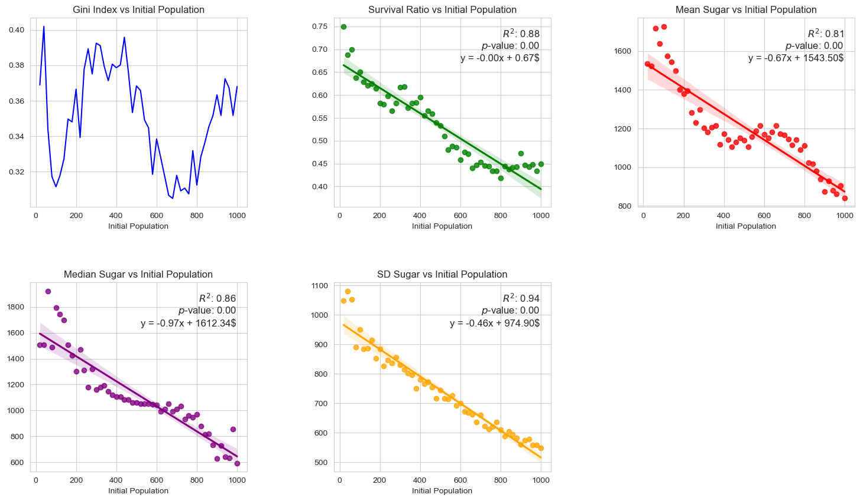

1. Population base experiment (Sugarscape2 )

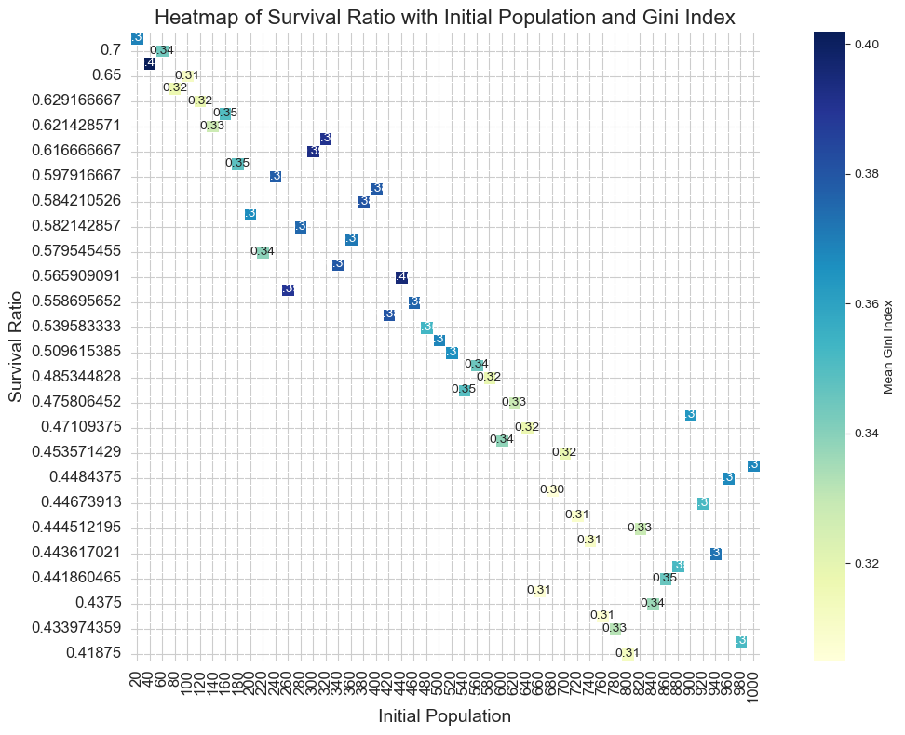

1. Heatmap of survival ratio with initial population and Gini index (Sugarscape2)

The simulation shows that the survival rate decreases as the population increases, indicating that the environment has a certain upper limit of population capacity. This is in line with the Malthusian population theory (Malthus and Winch, 1992). Without considering the aging mechanism, a population of around 100 appears to be optimal for wealth equality in society, while still maintaining a relatively high survival rate. When the population exceeds the environmental capacity, various problems will occur that endanger survival so that finding the right population size to maintain sustainable development is a real challenge.

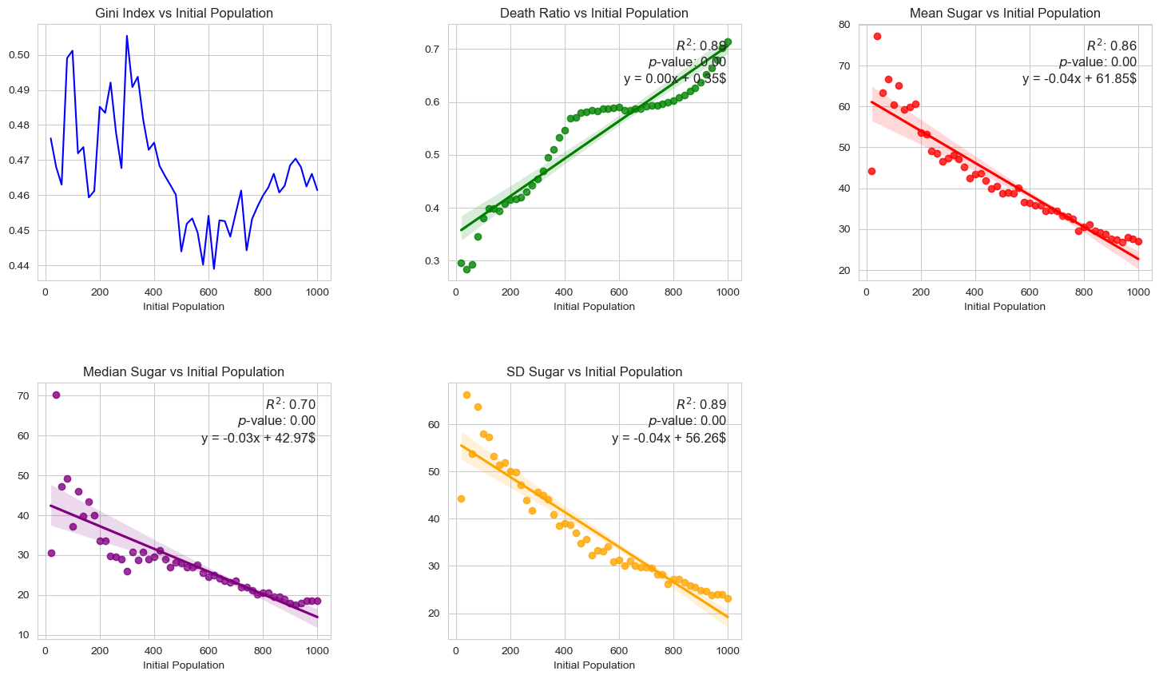

1. Population base experiment (Sugarscape3 )

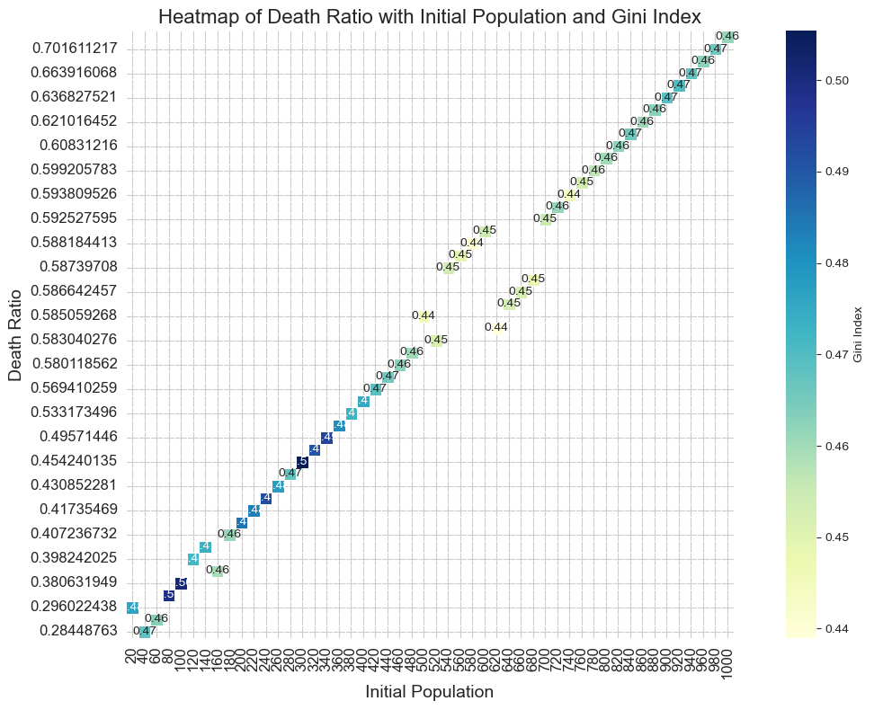

1. Heatmap of survival ratio with initial population and Gini index (Sugarscape3 )

3.2 Resource Allocation Experiment

In Sugarscape2, as the minimum resource allocation level increases, the overall Gini index tends to increase, especially when the maximum resource allocation level is high. It suggests that raising the minimum resource may exacerbate overall inequality, particularly with high maximum level. However, after introducing the aging mechanism, under certain high maximum resources, increasing the minimum leads to a decrease in the Gini coefficient, which indicates that the death and rebirth mechanism may help alleviate resource allocation inequality.

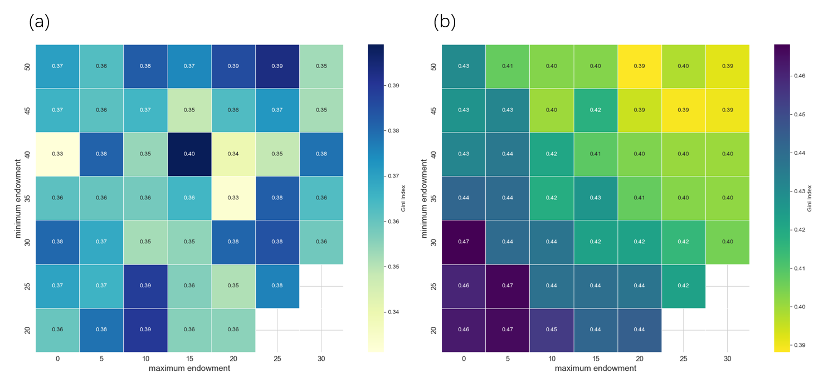

1. Heatmap of gini index with max-min sugar endowment.

(a) Sugarscape2 (b) Sugarscape3

Peak survival occurs at mid-level minimum sugar endowment (10-20) and high maximum (35-45). This means moderate starting resource differences and ensuring that most agents have sufficient initial resources, which is beneficial to improving overall survival rate. When the minimum endowment is very low (close to 0), survival rates drop sharply regardless of the maximum endowment. If some agents are in a state of extreme poverty from the beginning, it will seriously threaten the survival of the entire group.

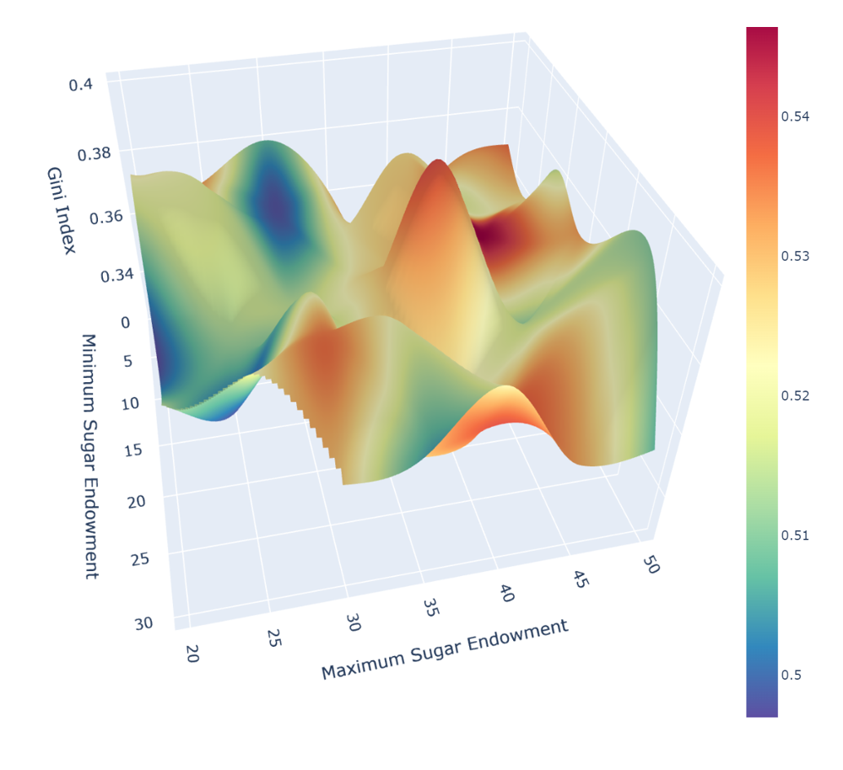

1. Relationship between the Gini index, survival ratio and the initial minimum and maximum sugar endowments (Sugarscape2 )

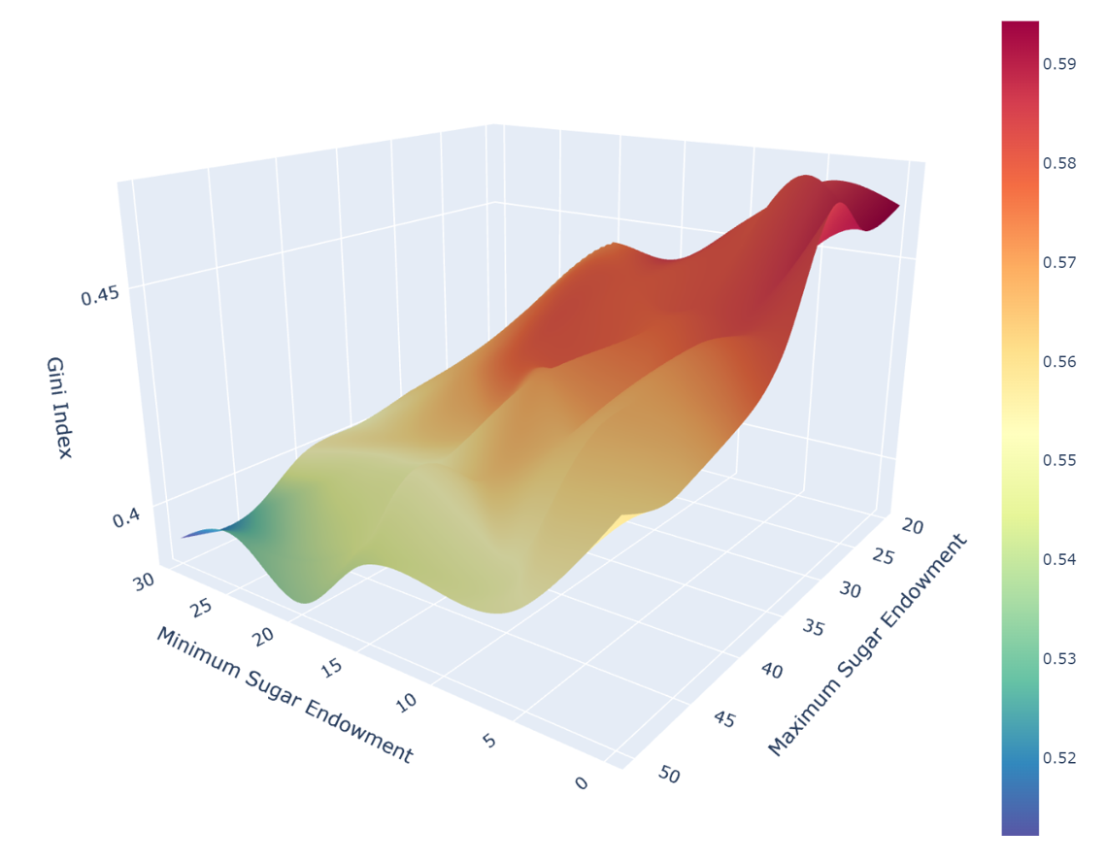

1. Relationship between the Gini index, death ratio and the initial minimum and maximum sugar endowments (Sugarscape3)

Figure 7 shows how the proportion of agents dying from starvation changes as a function of sugar endowment after introducing aging-death mechanisms. Hunger problems can be minimized by ensuring that all agents have basic starting resources and avoiding excessive wealth disparity. When the gap is small, starvation mortality also increases, because excessive equality will reduce the competitive motivation among agents and affect the ability to obtain resources.

These findings reveal that ensuring basic living standards, avoiding extreme poverty, and maintaining a moderate income gap may be the best policy combination to reduce hunger and improve the quality of life.

3.3 Combined Experiment

In Sugarscape2, the peak area of the Gini coefficient is concentrated in parameter combinations characterized by low initial population, low minimum resource, but high maximum endowment. This indicates that under such conditions of extremely unequal initial resource distribution, the gap between the rich and poor intensifies. However, as the minimum endowment or population increases, the Gini coefficient gradually decreases, suggesting a reduction in wealth inequality. Moderate population size and resource differences contribute to maintaining a relatively balanced distribution state.

After introducing the mechanism, the peak area shifts to moderate combinations of population and resource endowment. Extremely low minimum resources or excessively large populations lead to decreased Gini index, though overall wealth differentiation remains high. The surface shape becomes smoother with smaller fluctuations, indicating a more stable trend in wealth differentiation.

Comparing both scenarios, the introduction of mechanism intensifies the overall wealth gap. However, it also reduces the degree of wealth differentiation under extreme parameter combinations, making the results more concentrated. This suggests that the dynamic population mechanism may contribute to a redistribution and balancing effect of wealth.

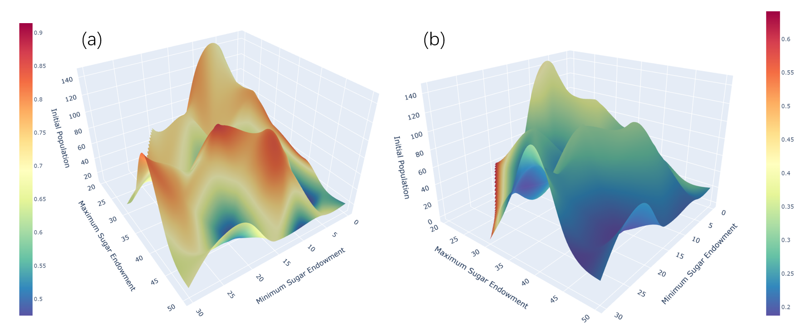

1. Survival/death ratio under different initial conditions

(a) Sugarscape2 (b) Sugarscape3

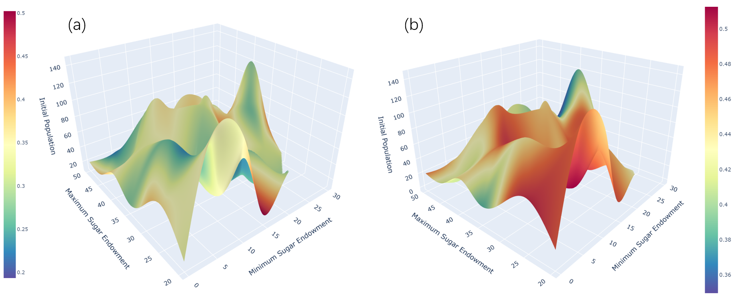

1. Gini index under different initial conditions

(a) Sugarscape2 (b) Sugarscape3

4 Discussion

Both Sugarscape models simulation demonstrate the Malthusian principle, illustrating the environmental carrying capacity beyond which the population cannot be sustained without leading to increased mortality. However, the introduction of an ageing-death parameter in Sugarscape3 provides a more dynamic balance, mirroring natural population renewal mechanisms. Policies aimed at sustainable development should consider the carrying capacity of the environment and resources (Hui, 2006). Overpopulation can lead to increased competition for limited resources, ultimately reducing overall well-being.

Meanwhile, a balance needs to be struck between ensuring a minimum standard of living (to avoid deaths from starvation) and maintaining a level of resource disparity (to stimulate competition and efficiency in resource use). Excessive equality as much as extreme poverty can harm the society by reducing the motivation for improvement or by increasing mortality rates, respectively. Excessive equality, as well as extreme poverty, can harm society by reducing motivation for improvement or increasing mortality rates, respectively. Thus, ensuring all members of society have access to necessities is essential for minimizing mortality due to resource scarcity and maintaining social stability.

The experiments highlight how different initial conditions of population size and resource distribution affect wealth stratification. In Sugarscape2, wealth distribution tends to become more equal under conditions of high population pressure, as resources are more uniformly distributed due to intense competition. However, this equalization may not necessarily improve overall well-being, as it could coincide with a general decrease in resource availability per capita. Conversely, model3 alters this dynamic, demonstrating that a moderate degree of wealth disparity, coupled with ensuring basic resources for all, can improve survival rates and reduce the intensity of wealth inequality. This suggests that a balanced approach, considering both resource distribution and population dynamics, is crucial for achieving sustainable development and societal well-being.

Future work on Sugarscape model includes comprehensive demographic factors, beyond merely introducing a maximum age for death, holds the potential to enrich its simulation of societal dynamics significantly. By embedding an age structure that delineates various life stages, the model can more precisely mirror the complexities of real-world societies. This addition would involve assigning distinct vision and metabolism rates to different age groups, thereby diving deeper in model's depiction of human behavior and social stratification.

5 Conclusion

The Sugarscape simulations and the contrast between Models 2 and 3, illustrate the complex interplay between population dynamics, resource distribution, and wealth inequality. These models show that achieving a sustainable, equitable society requires balances between ensuring a minimum standard of living for all and maintaining a level of economic disparity that encourages productive competition. The introduction of an ageing-death-birth mechanism in Sugarscape3 adds a realistic dimension to the simulation, offering deeper insights into how natural life cycles can impact wealth distribution and societal stability. These findings underscore the importance of informed policy-making that considers the multifaceted nature of wealth distribution, resource allocation, and population dynamics.

References

Axtell, R., Axelrod, R., Epstein, J. M. and Cohen, M. D. (1996). ‘Aligning simulation models: A case study and results’. *Computational & Mathematical Organization Theory*, 1 (2), pp. 123–141. doi: 10.1007/BF01299065.

Costopoulos, A. (2015). ‘How Did Sugarscape Become a Whole Society Model?’ in Wurzer, G., Kowarik, K., and Reschreiter, H. (eds) *Agent-based Modeling and Simulation in Archaeology*. Cham: Springer International Publishing (Advances in Geographic Information Science), pp. 259–269. doi: 10.1007/978-3-319-00008-4_11.

Epstein, J. M. and Axtell, R. (1997). ‘Artificial societies and generative social science’. *Artificial Life and Robotics*, 1 (1), pp. 33–34. doi: 10.1007/BF02471109.

Hui, C. (2006). ‘Carrying capacity, population equilibrium, and environment’s maximal load’. *Ecological Modelling*. Elsevier, 192 (1–2), pp. 317–320.

Li, J. and Wilensky, U. (2009). NetLogo Sugarscape 2 Constant Growback model. http://ccl.northwestern.edu/netlogo/models/Sugarscape2ConstantGrowback. Center for Connected Learning and Computer-Based Modeling, Northwestern University, Evanston, IL.

Li, J. and Wilensky, U. (2009). NetLogo Sugarscape 3 Wealth Distribution model. http://ccl.northwestern.edu/netlogo/models/Sugarscape3WealthDistribution. Center for Connected Learning and Computer-Based Modeling, Northwestern University, Evanston, IL.

Malthus, T. R. and Winch, D. (1992). *An essay on the principle of population*. Cambridge University Press Cambridge. Available at: https://bristoluniversitypressdigital.com/view/book/9781447342175/ch002.xml.

Appendix

The modified code, data visualization python file, and behaviour space output are in

https://github.com/yiyansun/Agent-based-modelling.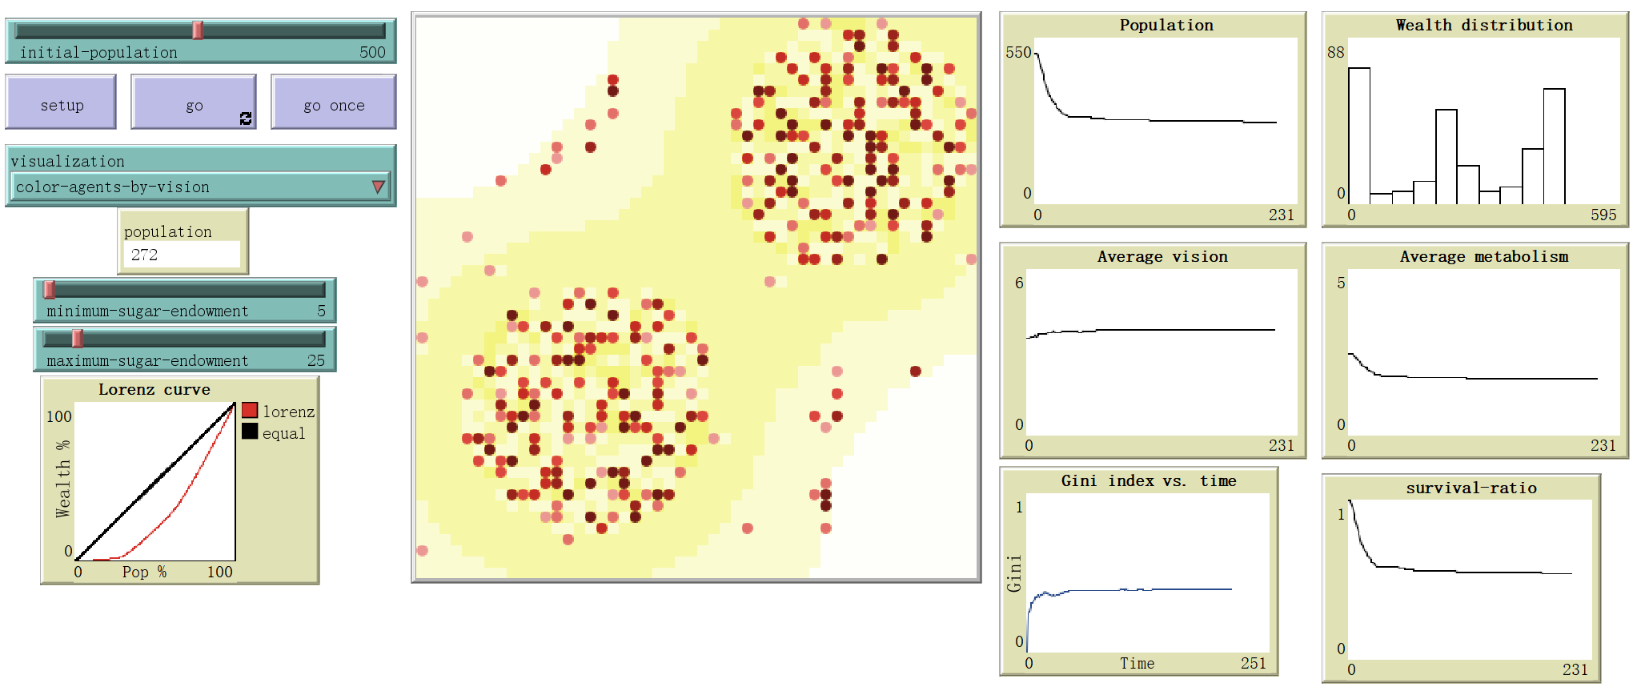

1. Behaviour Space (Sugarscape2)

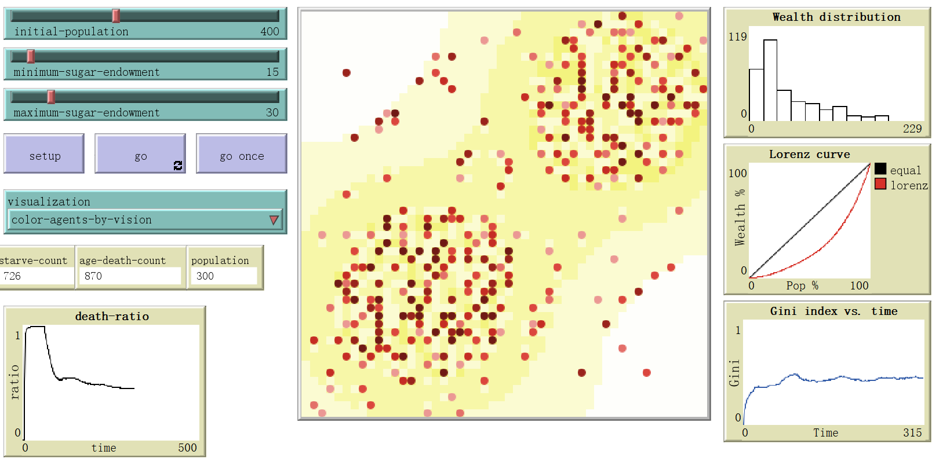

1. Behaviour Space (Sugarscape3)

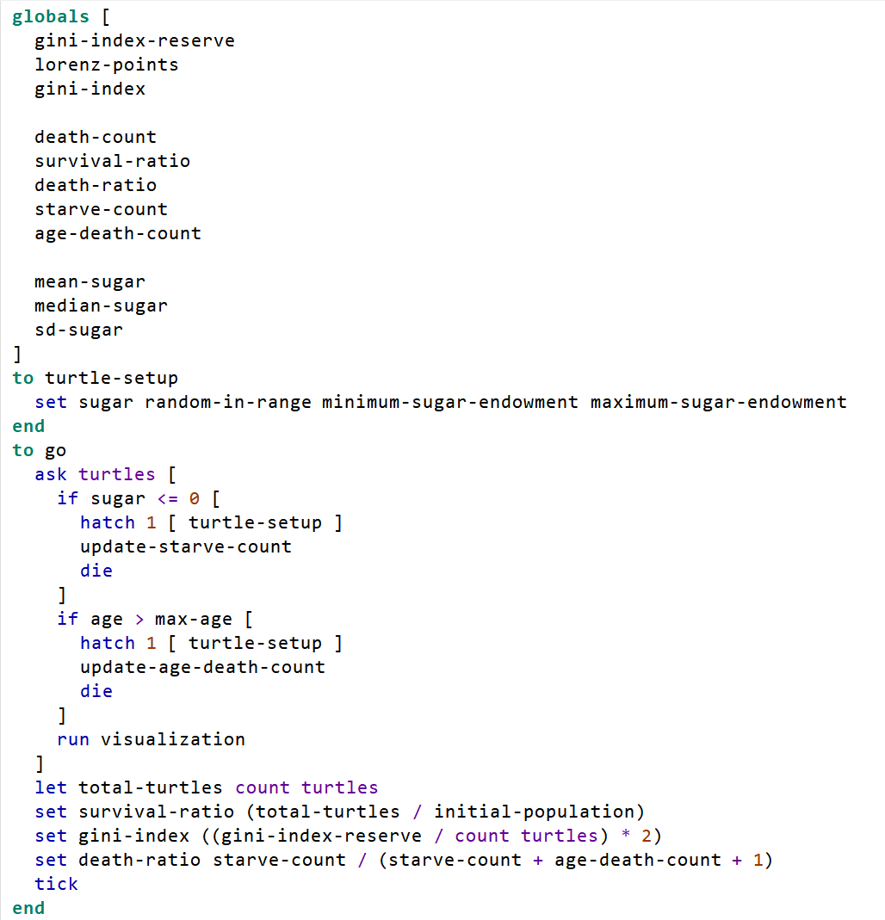

1. Modified part